Creating an Event Using
the 25Live Locations

Creating an Event Using the 25Live Locations
Overview
Using the online help
Keep in mind that you can always consult the online help if you have questions about what to do. Click the general “Help” button in the upper right of the page to access all Help topics, or click the Help icon in the navigation bar to access context-specific help for the current view or functional area.
Note: You must be signed into 25Live to access the online help.
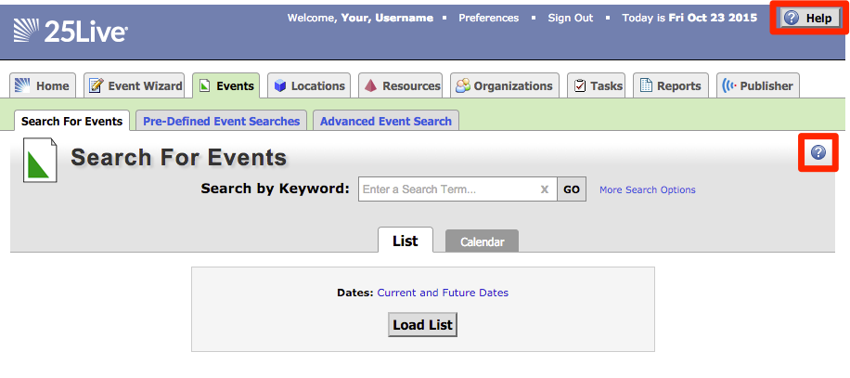

Opening the Locations Tab
To start creating an event through a location search, click the Locations tab to open.
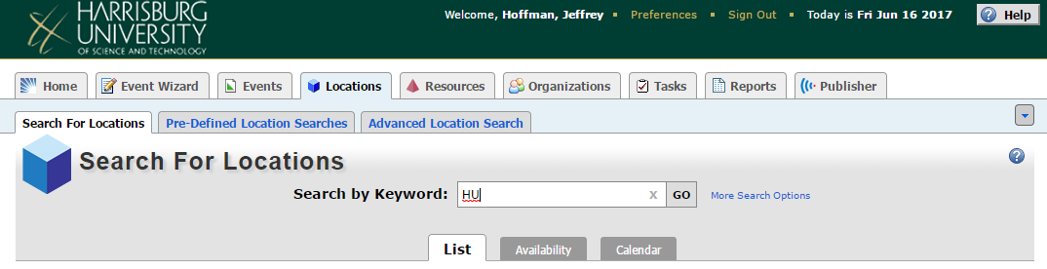

Search by Keyword
Enter a Search Term into the Search by Keyword textbox on the Search For Locations subtab.
* All individual classroom and meeting room spaces begin with the keyword “HU” followed by a space and then the room number. Other applicable keywords are: “14th Floor” and “Cafe’ Area”
* You can also just search by room number. Example: “1302” for Classroom 1302.
Click “GO” to return your search results.

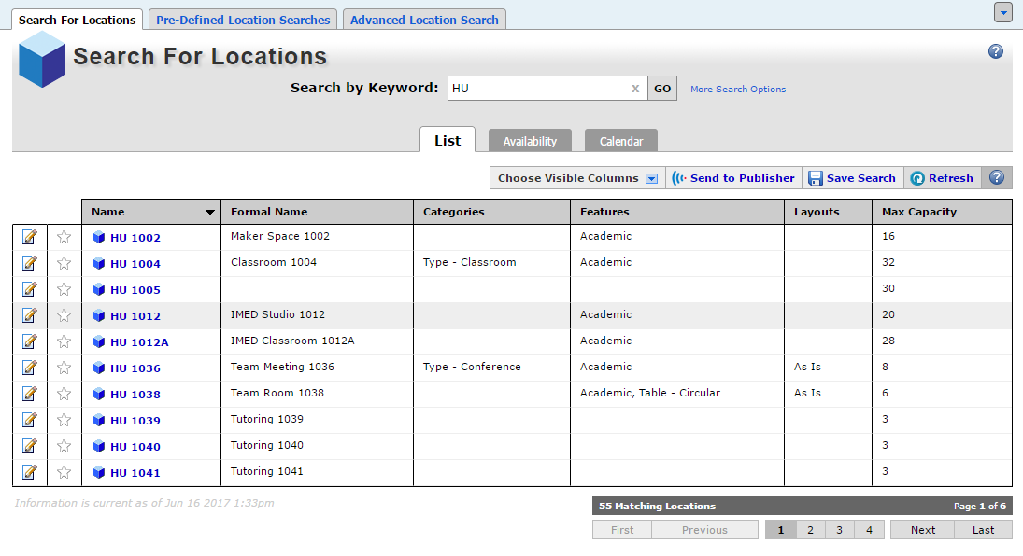

Schedule an Event by Returned Location
Click on the icon to schedule an event for the corresponding location.
You will be redirected to the first step of the Event Wizard with the location already pre-assigned.
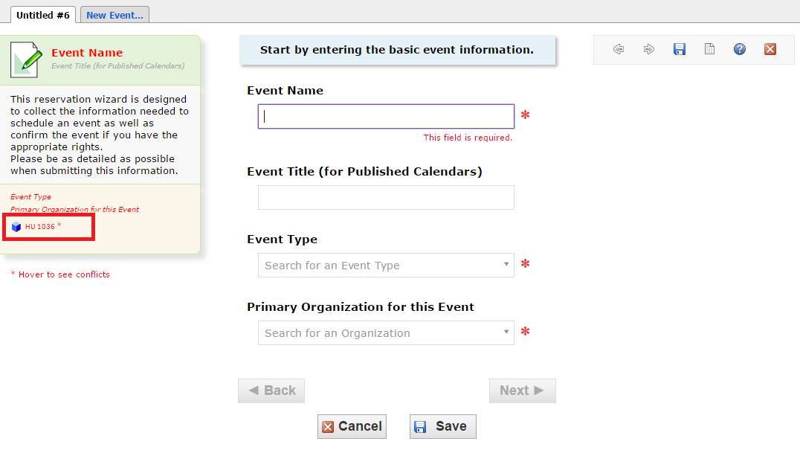

Click “Next” through the Event Wizard to create your event.
NOTE: See 25Live_CreatingEventUsingEventWizard document for more information on using the Event Wizard.
Click “Save” on the final step to submit your event into the calendaring system.

Schedule an Event by Returned Location from Room Details
You can click on the hyperlinked location name in the Name column to bring up additional details about the location.
Under Actions, click on the ‘Create an Event in this Location’ option.
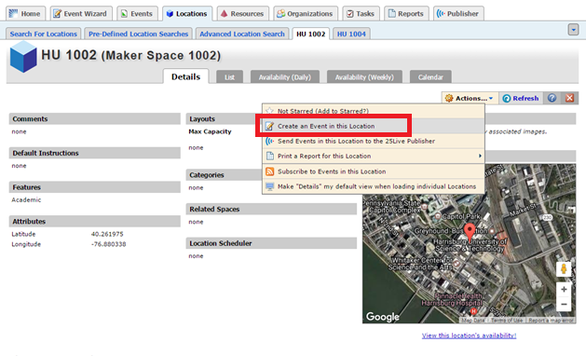
You will be redirected to the first step of the Event Wizard with the location already pre-assigned.
Click “Next” through the Event Wizard to create your event.
NOTE: See 25Live_CreatingEventUsingEventWizard document for more information on using the Event Wizard.
Click “Save” on the final step to submit your event into the calendaring system.

