Creating an Event Using
the 25Live Event Wizard

Creating an Event Using the 25Live Event Wizard
Overview
Note: Our 25Live® environment has been specifically customized to our institution's needs, so the examples in this document may not match our specific details.
Using the online help
Keep in mind that you can always consult the online help if you have questions about what to do. Click the general “Help” button in the upper right of the page to access all Help topics, or click the Help icon in the navigation bar to access context-specific help for the current view or functional area.
Note: You must be signed into 25Live to access the online help.
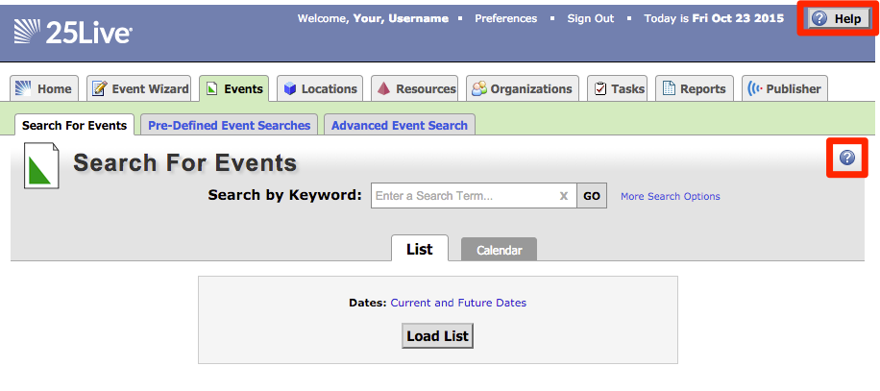

Opening the Event Wizard
To start creating an event, click the Event Wizard tab to open the wizard.
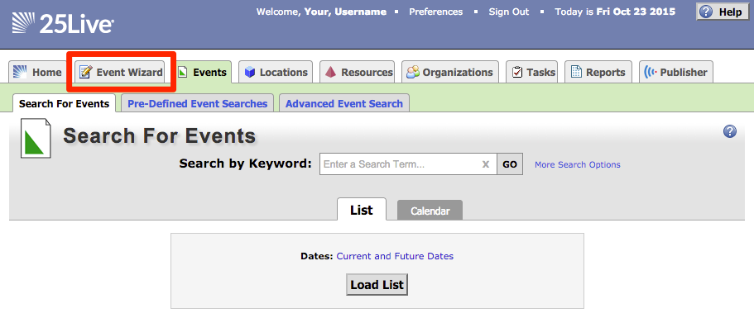

Entering basic information
Enter an Event Name, and select an Event Type and Primary Organization. The Event Name is how the event will appear on web calendars (if set up in your 25Live Configuration) and in searches. Permissions determine which Event Types you can choose from.

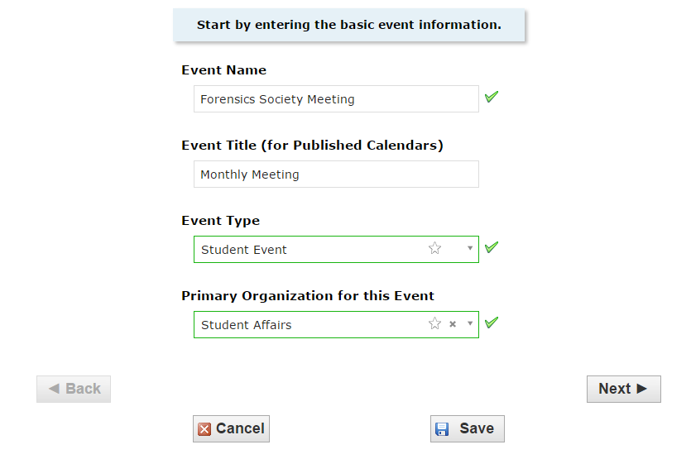

Click “Next” to enter additional basic information.

Enter additional basic information
Enter the event’s expected attendance and event description. The Expected Attendance will be used by 25Live to find locations that can hold your event. The Event Description can appear on web calendars if you intend to publish your event.
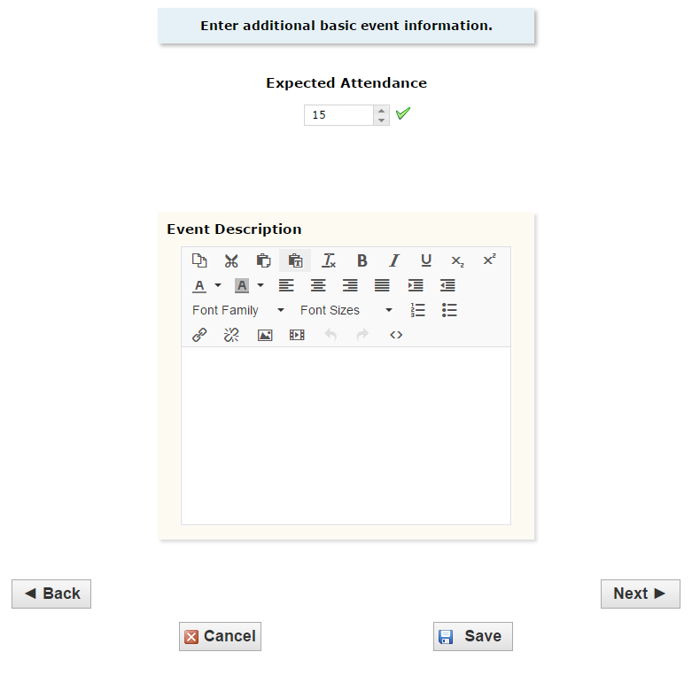

Click “Next” to add event occurrence information.
Does the event repeat?
If the event has only one occurrence, select “No;” if it has more than one occurrence, select “Yes.”

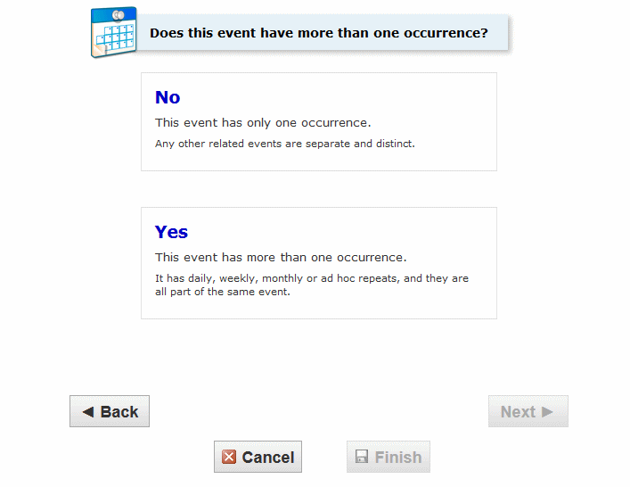

Click “Next” to set the event start/end date and time.

When is the first occurrence?
Specify the date and times of the first occurrence of the event. If your event occurs on multiple days, you’ll describe how it repeats later. If your event has multiple occurrences that happen at different times, you’ll need to create separate events for each time. You can then connect those events to each other later using Manage Related Events functionality.
If the event requires Setup/Pre-Event and/or Post-Event/Takedown time, select the option you need, then set the number of days, hours, or minutes needed.

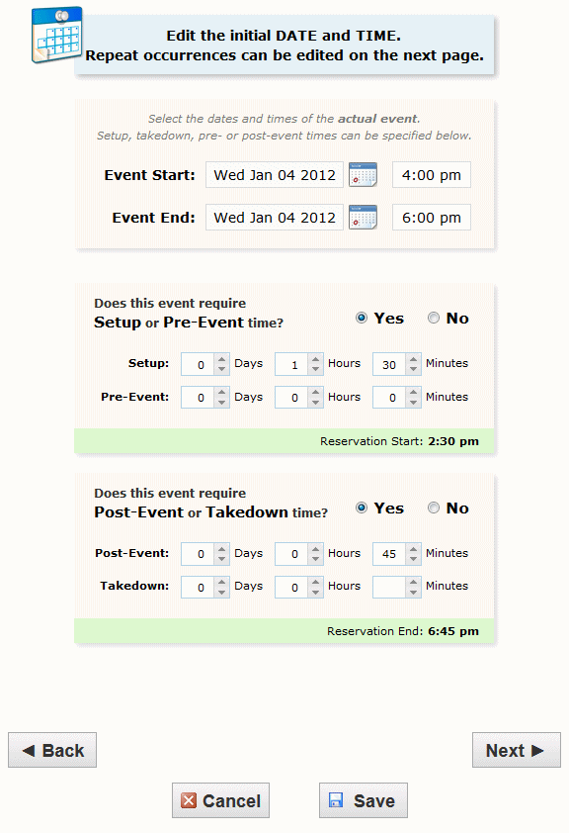

Click “Next” to set up multiple event occurrences, or if the event has only one occurrence click “Next” to select the event’s Location.
How does the event repeat?
If your event has more than one occurrence, select how the event repeats.

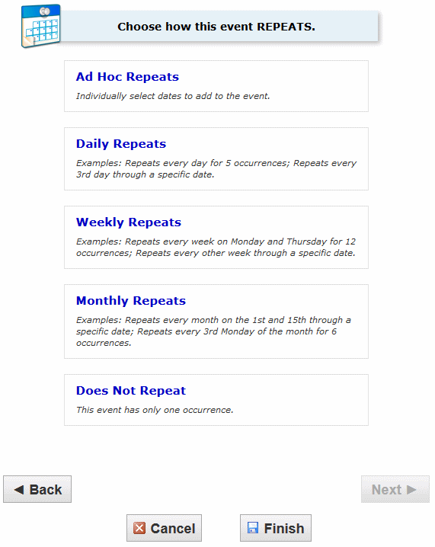

Click “Next” to set the event’s occurrence dates.

Define the exact dates of the event
Use the repeat date controls to define the event’s repeating pattern or ad hoc dates. Once defined, you see the dates in the Occurrence List at the bottom of the page.

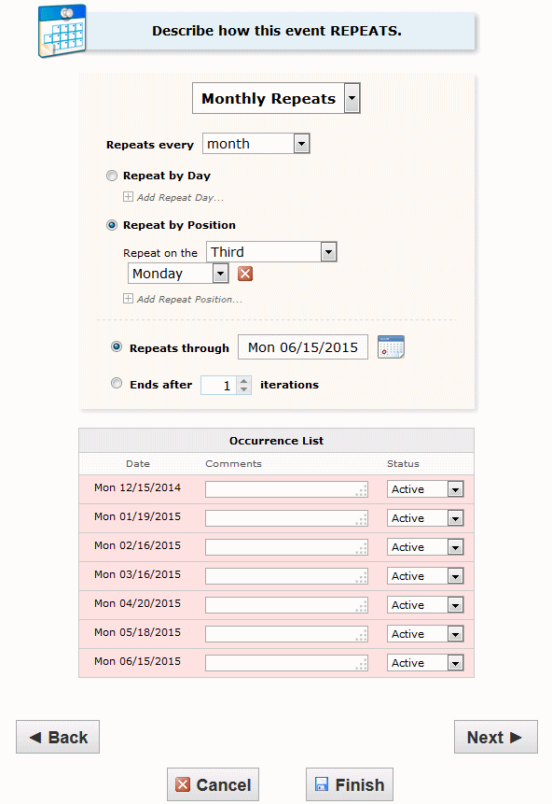

Click “Next” to select the event’s location(s).
Select location(s)
Select one or more favorite “starred” locations, or search for suitable locations by location name, saved search, or advanced search. Locations that best fit your head count will appear higher in the list. If you’ve searched, choose one or more available locations for your event.
A red triangle means the location is not available. A green check mark means the location is available. A green box with lines inside means the location is in use, but the event that is using it is willing to share the location.
If you need to un-assign a location for specific occurrences, choose a different layout, or add setup instructions, click “View and Modify Occurrences” on the right and perform the required task(s).

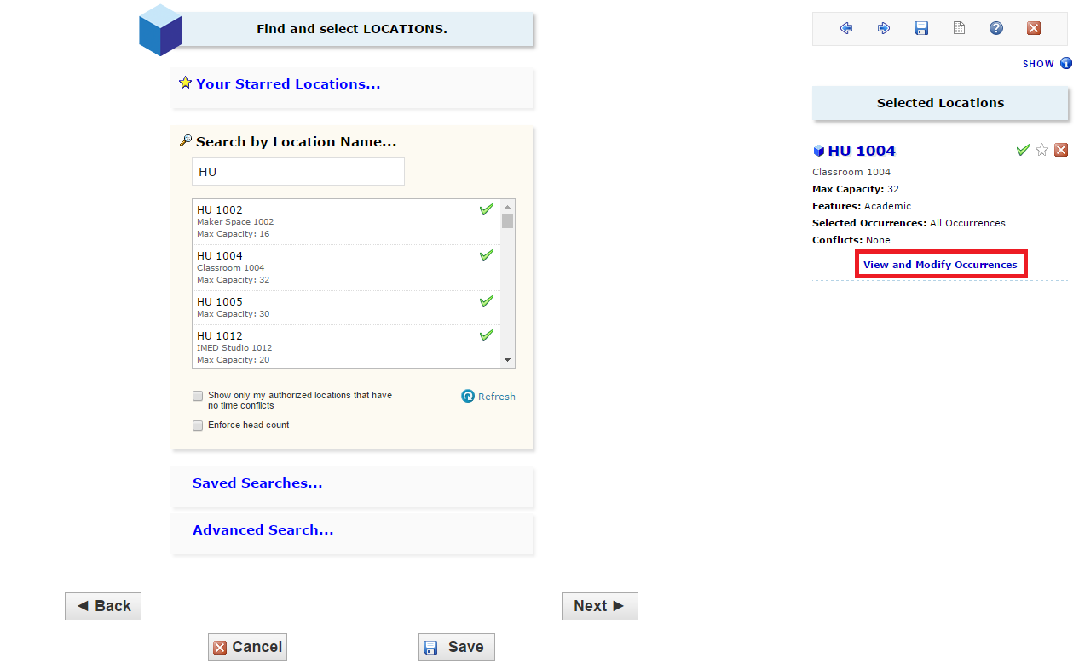

Click “Next” to select the event’s resource(s).
Select resource(s)
Select one or more favorite “starred” resources, or search for resources by resource name, saved search, or advanced search. If you’ve searched, choose one or more available resources for your event.
A red triangle means the resource is not available. A green check mark means the resource is available.
If you need to adjust the quantity of a resource needed for specific occurrences, un-assign a resource for specific occurrences, or add setup instructions, click “View and Modify Occurrences” on the right and perform the required task(s).

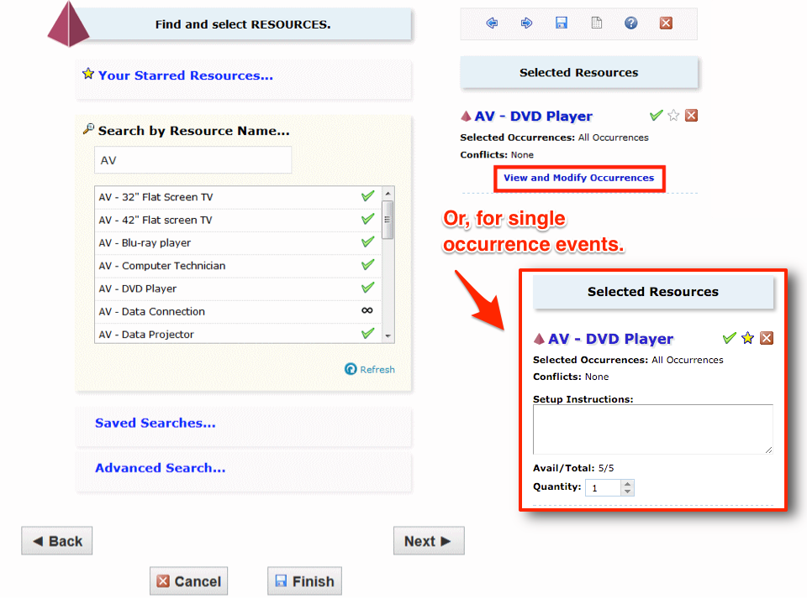

Click “Next” to select the event’s custom attributes.

Enter custom attributes
Select and enter values for the custom attributes listed that are pertinent to your event. These custom attributes, NAMES GO HERE are very important when creating events at YOURSCHOOL.

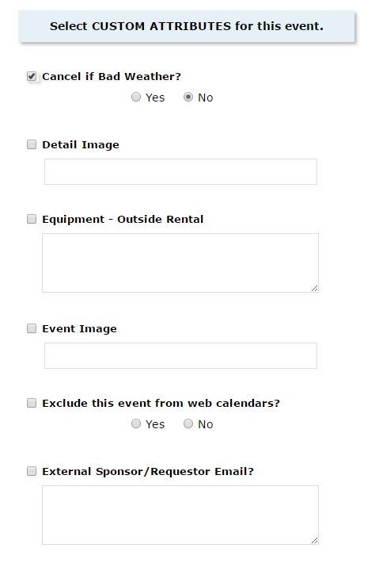

Click “Next” to select the event’s contacts.

Select contacts
Select the contacts associated with the event. If you’re not the primary contact for the event, you need to specify who is. To specify a contact, click the drop-down icon and enter a few letters of the contact’s name, then select it when the full name displays. You can also add a name by selecting “Create New…,” and then entering the contact’s “Basic Information” and “Email” address.
The scheduler may be automatically assigned to your event depending on security; this might be the Location Scheduler for your selected location or the default scheduler for your security group.

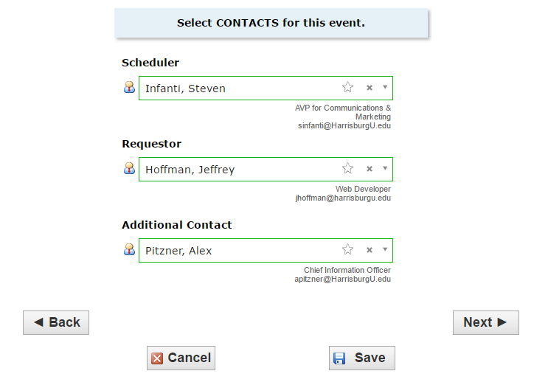

Click “Next” to select the event’s categories.

Add Comments and Notes
Enter appropriate comments and/or notes for the event.
- Event Comments can be seen by most users.
- Confirmation Notes are shown in Confirmation Reports.
- Internal Notes can be seen only by people who are event contacts, like Requestor and Scheduler.
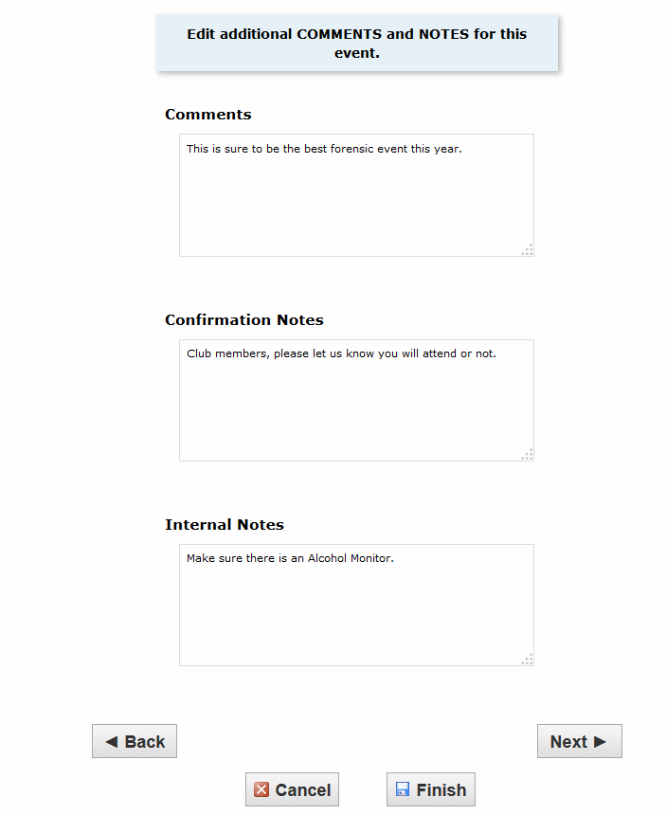

Click “Next” to agree to event terms and conditions.
Choose event state
Choose the appropriate state of your event, then click Finish.
You may be required to save your event as a draft, in which case any locations and/or resources you’ve requested will be saved as preferences, not assignments.
Tentative and Confirmed events can have assigned locations and resources.

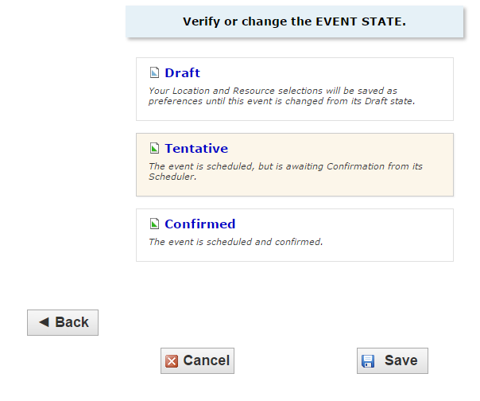

Click “Save” to complete the event creation.

